Math 1 Name ______________________________
5-5 Properties of Quadrilaterals Date _______

- I can determine the type of quadrilateral based off the given property(s).

1. Lines that are parallel have _________________ slopes. SKETCH:

2. Lines that are perpendicular have slopes that are _______________ ________________________. SKETCH:

3. PROPERTIES OF QUADRILATERALS –
 | Parallelogram | Rectangle | Rhombus | Square
2 pairs of opposite sides parallel
2 pairs of opposite sides congruent
All 4 sides congruent
All 4 angles congruent

4. In order to call a quadrilateral a parallelogram what must be true of the quadrilateral? Sketch one and label defining features:

5. In order to call a quadrilateral a rectangle what must be true of the quadrilateral? Sketch one and label defining features:

6. In order to call a quadrilateral a rhombus what must be true of the quadrilateral? Sketch one and label defining features:

7. In order to call a quadrilateral a square what must be true of the quadrilateral? Sketch one and label defining features:

8. Below is a hierarchy of quadrilaterals we will study. Write the names on each of the figures and mark parallel sides, lengths that are the same size and angles that have the same measure.

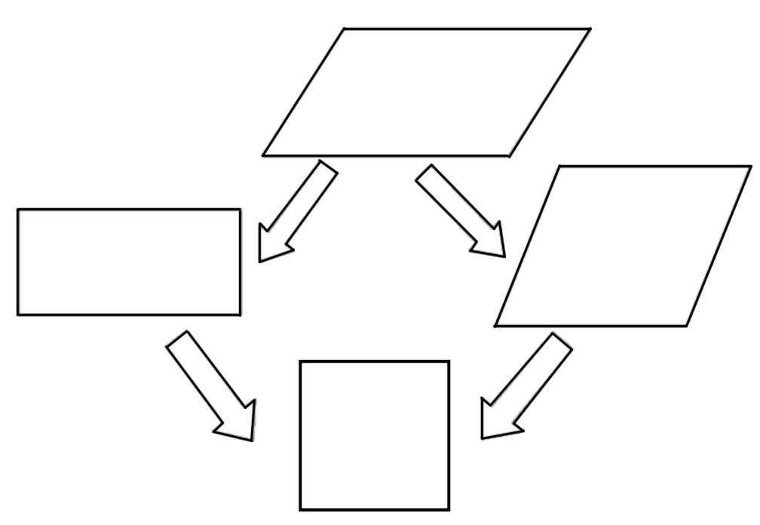
The questions below provide hints as to which quadrilateral they are describing. Name all of the quadrilaterals that they could be describing.

9. My definition says that I have four sides of equal length.

10. My opposite angles are congruent.

11. My opposite sides are the same length, but my consecutive sides are not.

12. I have four right angles.

13. All of my sides are equal length, but not all of my angles are.

14. Based off my angles, I could be a rectangle and based of my sides, I could be rhombus.

15. I have four angles with the same measurement, but my side lengths are not all the same length.

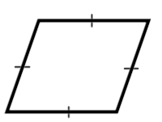
16. Identify the quadrilaterals below.

____________________ ____________________



 

